|  |  |  |
| --- | --- | --- |
|  | **DATA FLOW DIAGRAMS AND USER STORIES** | |
|  |  |  |
| Date |  | 08th November, 2022 |
|  |  |  |
| Team ID |  | PNT2022TMID48243 |
|  |  |  |
| Project Name |  | A Novel Method for Handwritten Digit |
|  |  | Recognition System |
|  |  |  |
| Maximum Marks |  | 4 Marks |
|  |  |  |

**Data Flow Diagrams:**

A Data Flow Diagram (DFD) is a traditional visual representation of the information flows within a system. A neat and clear DFD can depict the right amount of the system requirement graphically. It shows how data enters and leaves the system, what changes the information, and where data is stored.

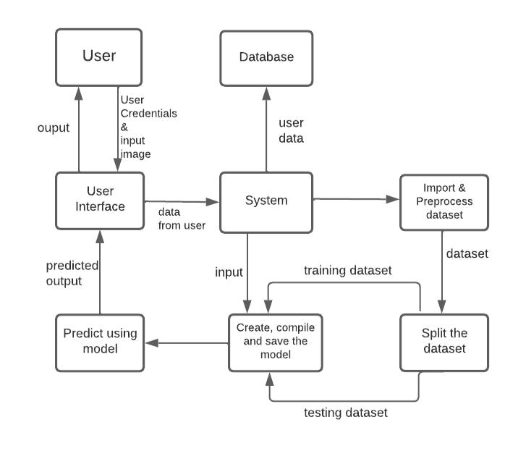

1. User registers with their credentials
2. Input from the user
3. System loads the dataset
4. Splitting into training and testing
5. CNN modelling
6. Output prediction
7. Display the output

|  |  |  |  |  |  |  |
| --- | --- | --- | --- | --- | --- | --- |
| **USER** | **FUNCTIONAL** | **USER** | **USER** | **ACCEPTANCE** | **PRIORITY** | **RELEASE** |
| **TYPE** | **REQUIREMENT** | **STORY** | **STORY/TASK** | **CRITERIA** |  |  |
|  | **(EPIC)** | **NUMBER** |  |  |  |  |
| Customer | Registration | USN1 | I should register | I can access my | High | Sprint-1 |
|  |  |  | with my | account via email |  |  |
|  |  |  | credentials like |  |  |  |
|  |  |  | username, email |  |  |  |
|  |  |  | and passwords |  |  |  |
|  |  |  | as a customer |  |  |  |
|  | Verification | USN2 | As a customer I | I can verify my | High | Sprint-1 |
|  |  |  | will verify my | registration |  |  |
|  |  |  | registration with | through my email |  |  |
|  |  |  | email received |  |  |  |
|  | Login | USN3 | I, as a customer, | I can login the | Low | Sprint-2 |
|  |  |  | should login | page |  |  |
|  |  |  | with my |  |  |  |
|  |  |  | credentials |  |  |  |
|  | Upload Input | USN4 | I will upload | I can write the | High | Sprint-2 |
|  |  |  | my input as an | digit or upload |  |  |
|  |  |  | image or via on | the image |  |  |
|  |  |  | -screen mode |  |  |  |
|  | Train | USN5 | As a customer I | I can upload | Medium | Sprint-3 |
|  |  |  | will train the | proper images |  |  |
|  |  |  | system | frequently to |  |  |
|  |  |  | thoroughly with | train the system |  |  |
|  |  |  | proper and |  |  |  |
|  |  |  | frequent inputs |  |  |  |
|  | Test | USN6 | As a customer I | I can check he | High | Sprint-3 |
|  |  |  | will test the | system accuracy |  |  |
|  |  |  | system | with my fresh |  |  |
|  |  |  | periodically | data |  |  |
|  |  |  | with new data |  |  |  |
|  |  |  | to check the |  |  |  |
|  |  |  | system accuracy |  |  |  |
| Administrator | Maintenance | USN7 | As an admin I | I can handle the | High | Sprint-4 |
|  |  |  | will maintain | customer data |  |  |
|  |  |  | the user data |  |  |  |
|  |  |  | properly |  |  |  |
|  | Update | USN8 | As an | I will update the | Medium | Sprint-4 |
|  |  |  | administrator I | system when it is |  |  |
|  |  |  | will check if I | required |  |  |
|  |  |  | can make any |  |  |  |
|  |  |  | effective |  |  |  |
|  |  |  | updates on the |  |  |  |
|  |  |  | system |  |  |  |